1.(1.sql) List books that have title start with character S ordered by their types. /

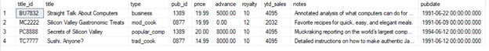

2.(2.sql) List books that have the advance is more than twice the average for the group as below /



3.(3.sql) List all years and the number of titles published for each year, including the total number of titles published by all publishers as below /

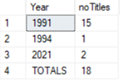

4.(4.sql) List total quantity, total amount of each title was sold by each store as below. /

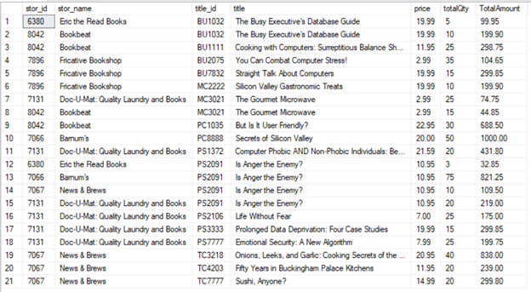

5.(5.sql) List employees that have the third character of the first name is ‘A’ as below /



6.(6.sql) List years that have the maximum number of titles were published as below /



7.(7.sql) Find those titles that have the ytd_sales greater than of title 'Silicon Valley Gastronomic Treats' as below.

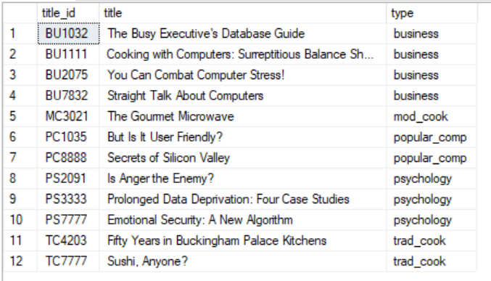

8.(8.sql) List employees hired by the publisher 'Binnet & Hardley' from 1990 to 1992 as below.

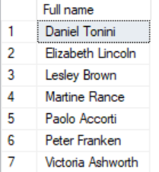

9.(9.sql) List all titles, and their sold number, including the sold total number of titles at the end. Use row_number() for the column [row].

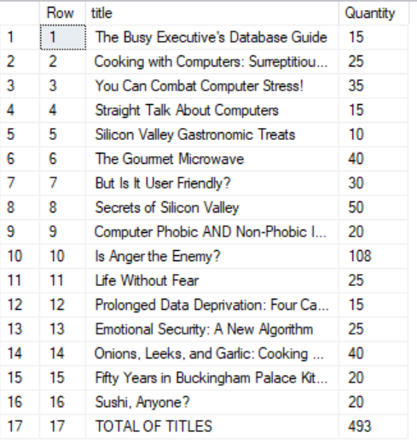

10.(10.sql) List all authors, and their number of titles, including the total number of titles at the end. Only count 1 for each title, even one title can be written by more than one author as below. Use row_number() for the column [row].

